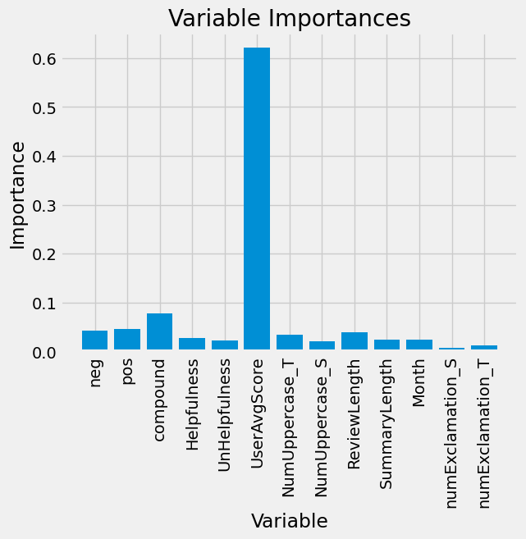

**When we use just neg and pos values as predictors:**

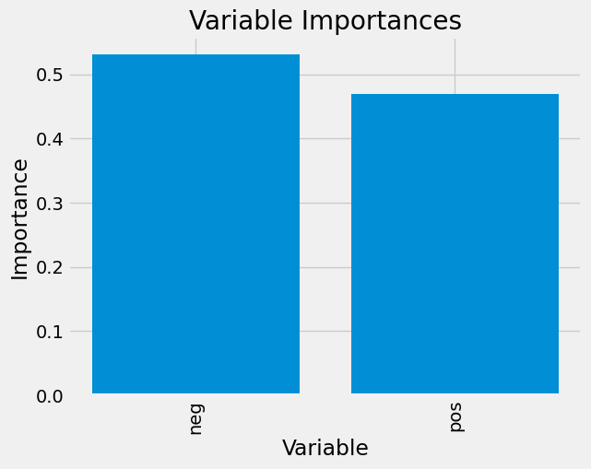

MSE on train:

0.6579892988515167

MSE on test:

1.7495597754739438

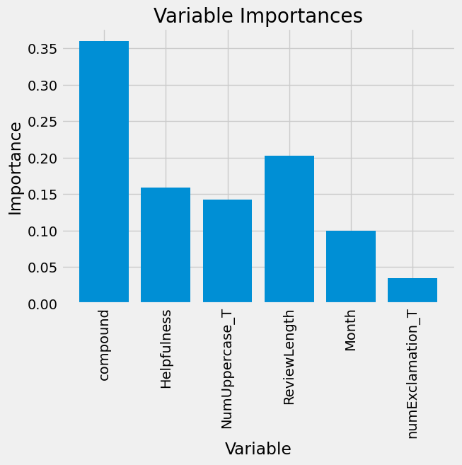

MSE on train:

0.002894058699345761

MSE on test:

2.0162100112089414